

**Table of Contents**

Release version 4.1

A guide for the Plastic SCM distributed system

Plastic SCM **Distributed**

© 2006-2012 Codice Software

Warning and Disclaimer

Every effort has been made to make this book as complete and as accurate as possible, but no warranty or fitness is implied. The information provided is on an “as is” basis. The author and the publisher shall have neither liability nor responsibility to any person or entity with respect to any loss or damages arising from the information contained in this book.

Trademarks

All terms mentioned in this book that are known to be trademarks or service marks have been appropriately capitalized. Codice Software cannot attest to the accuracy of this information. Use of a term in this book should not be regarded as affecting the validity of any trademark or service mark.

Table of Contents 4

1 Overview 1

2 Branch replication 3

3 Distributed scenarios 5

3.1 Multi-site replication with mastership policy 5

3.2 Multi-site replication with shared mastership 9

3.3 Pure distributed scenario 10

4 How replication works 11

4.1 Replication in detail 11

5 Replication modes 14

6 Replication from the command line 16

6.1 Direct server replication 16

6.2 Replication packages 16

7 Authentication 18

7.1 Setting up authentication modes 18

7.2 Translating users and groups 21

8 Replication from the graphical interface 24

8.1 Replication actions 24

8.2 Replication menu 25

8.3 Pushing your changes to a remote repository 26

8.4 Synchronizing your branch with remote changes 27

8.5 Importing a remote branch 28

8.6 Managing remote authentication 29

8.7 Running the replication process 30

8.8 Creating a package 31

8.9 Importing a replication package 32

9 Distributed Branch Explorer 33

9.1 How the DBrEx works 33

9.2 Rendering multiple repository sources on the DBrEx 34

9.3 Diffing remote branches and changesets 36

9.4 Enabling the DBrEx for a single branch 37

10 Synchronization View 38

10.1 Creating a new Sync View 38

10.2 Source and destination explained 40

10.3 Sync view details 41

10.4 Several sources and destinations on a single view 41

**Figures**

Figure 1. Deployment scenarios supported 1

Figure 2. Branch replication between two locations 3

Figure 3. Multi-site read-only 6

Figure 4. Multi-site scenario with master integration (I) 8

Figure 5. Multi-site scenario with master integration (II) 8

Figure 6. Multi-site replication with changes performed in parallel 9

Figure 7. Fully distributed scenario in detail 10

Figure 8. Replication: step by step explanation. 12

Figure 9. Replication of branches modified at two locations 13

Figure 10. Replication modes 15

Figure 11. Distributed system authentication diagram 19

Figure 12. Specifying credentials to replicate between servers 19

Figure 13. Two different ways to specify authentication credentials 20

Figure 14. UP server communicating with LDAP one 21

Figure 15. User and group translation on replication 22

Figure 16. Translation table explained 23

Figure 17. GUI replication actions 25

Figure 18. Replication options in GUI branch menu 26

Figure 19. Pushing changes 27

Figure 20. Pull changes from a remote branch 28

Figure 21. Pull a remote branch 29

Figure 22. Advanced options dialog – I3 visual theme 29

Figure 23. Profile selection dialog – I3 visual theme 30

Figure 24. Replication operation progress – I3 visual theme 31

Figure 25. Create replication package from the GUI 31

Figure 26. Import a replication package 32

Figure 27. Distributed scenario with two servers 33

Figure 28. DBrEx draft 34

Figure 29. Options to combine remote repositories on the DBrEx 35

Figure 30. Remote changesets rendered on the branch explorer 36

Figure 31. Menu options (diffing) on remote changesets 37

Figure 32. Single branch extended with remote information 37

Figure 33. Sync view entry point on the menu 39

Figure 34. Creating a new sync view 40

Figure 35. Sync view details 41

Figure 36. Available menus for sync view details 41

Figure 37. More than one source/destination pair on a sync view 42

# Overview

This guide explains Plastic SCM’s capabilities when it comes to working with distributed systems. It contains a general description of the different distributed scenarios supported, followed by detailed explanations. Replication scenarios are also covered in-depth.

Plastic SCM’s distributed capabilities allow you to set up different servers for multi-site development support, which are able to both replicate and reconcile changes made on replicated branches.

Plastic SCM has the ability to create different multi-site scenarios ranging from single-server to fully distributed deployments.

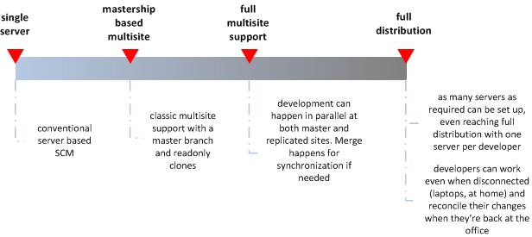

Figure 1. Deployment scenarios supported

As Figure 1 shows, Plastic SCM can be configured to work in a single server mode, which is the default mode on installation and the conventional mode available on all SCM products.

The next step has been called *classic multisite* in which several servers exist – one for each development location – and contents are replicated among them. The basic rule at this *distribution* stage is that *branch mastership* is kept by only one site at a time. If a branch is modified at one site, the other sites won’t modify it until the branch is replicated again. In many systems, this behavior is encouraged by the software itself, preventing simultaneous changes in a *master/slave* relationship. Plastic SCM does not restrict you to working in this mode, though you can use both permissions and a clear replication policy to simulate it, should you find this configuration useful.

Full multisite support is almost identical to the previous distribution stage with only one difference: All the SCM servers can modify their branches at any time. Changes can be reconciled back later on if the same branch is modified more than once at different locations.

Full distribution is exactly the same as full multisite, but on this deployment scenario each developer has his own SCM server. There’s only one restriction imposed on systems working in this mode: Servers must be light enough to run on non-dedicated workstations and even laptops. Plastic SCM servers can easily be configured to work in this mode, introducing full disconnected support. A developer can take his laptop home and continue working as if he were at the office and reconcile his work when he’s back at the office.

# Branch replication

The main operation in distributed systems is *replication*. By means of this operation, repositories can be distributed on several machines. The replication unit in Plastic SCM is the branch. Users specify which branch they want to work with and replicate it from a source repository to a destination repository. All revisions, labels, links, attributes, and changesets will be replicated to the destination.

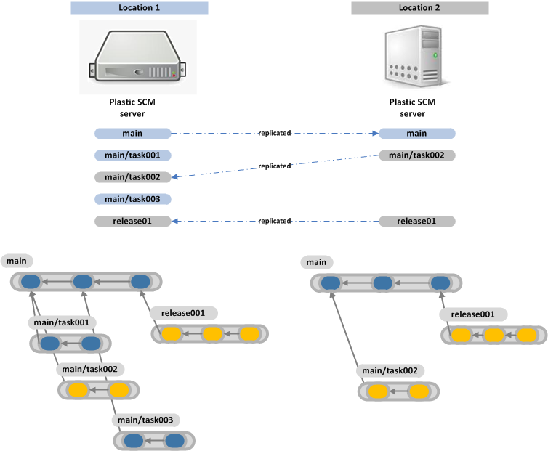

Figure 2. Branch replication between two locations

Figure 2 shows two repository servers at two different locations. The server at *Location 2* has replicated the branch *main* from *Location 1*. Then a developer at Location 2 has created another two branches which have been replicated back into *Location 1* later on.

As you can see from the figure, distributed repositories don’t have to be exact clones. They share *replicated* branches and their contents but the entire repositories don’t have to be identical. Instead, they can evolve separately, sharing only some branches.

# Distributed scenarios

There are several possible distributed scenarios with Plastic SCM. They will be explained in detail in this chapter.

## Multi-site replication with mastership policy

In this scenario, two or more servers are used in replication. Servers will normally run at different locations to enable geographically distributed teams to work together on the same project. A server at each location will solve the problem of slow or unreliable internet connections between sites.

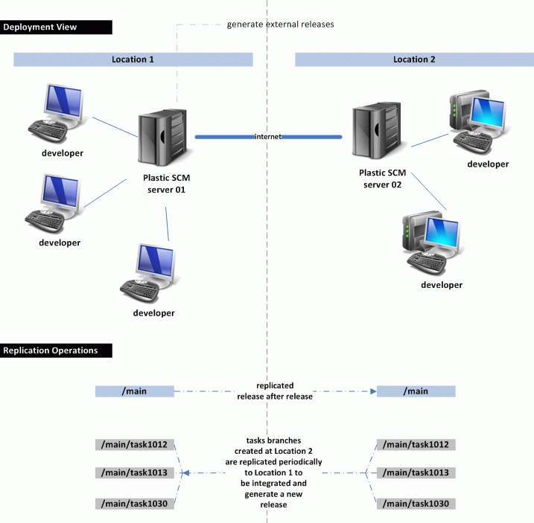

Figure 3. Multi-site read-only

Figure 3 shows both a deployment diagram and a detailed view of the branching strategy. This set up resembles *classic* multi-site replication as implemented by many *master/slave* based products. In Plastic SCM, this scenario is just one possibility and it will be used to explain replication.

The two sites, *Location 1* and *Location 2,* will have their own servers. Both sites will be working on the same code-base, so developers will need to be able to check in changes at any time. The chosen strategy would be this:

* Both servers will have an exact replicated copy of the main branch, containing the latest baseline.
* The new baselines will be generated only in one server at a time, so they will be implementing a sort of *mastership* behavior. Let’s assume new baselines will be created on *server 01*.
* Developers at both locations will follow the *branch-per-task* pattern. Branches will be created using the latest baseline as a starting point. The two teams agree that the main branch won’t be modified in parallel at the two sites.
* Periodically (maybe twice a week, depending on the amount of work completed) all the *task-branches* created at *Location 2* will be replicated into *Location 1*. All branches will be integrated on the main branch, tested, and a new baseline will be created. Alternative integration branches could exist at each site in order to ease the integration process.
* Once the release is finished, the main branch will be replicated from *Location 1* to *Location 2* and a new development iteration will begin.

Figure 3 shows how branches are replicated from *Location 2* to *Location 1* in its lower area.

Figure 4 and Figure 5 describe the previous scenario step by step. They show how the main branch is first replicated from *Location 1* into *Location 2*, how the newly created release *58* is then available to the two development groups.

Then the groups start working on and creating *task branches* independently from each other, but starting at a well-known point: *release 58*.

Once the iteration is finished, branches *task1012*, *task1013* and *task1030* created at *Location 2* are replicated to *Location 1* to be integrated.

Once the integration is finished, the branch /*main* will be replicated again to *Location 2*, so that the development group there can continue working with the latest approved baseline.

Note that both repositories are not identical after the development iteration finishes, but the content on the main branches, considering they’re being modified at only one site, is exactly the same.



Figure 4. Multi-site scenario with master integration (I)



Figure 5. Multi-site scenario with master integration (II)

## Multi-site replication with shared mastership

The deployment required for this scenario is exactly the same as in the *mastership* case. The difference will be the way in which the replicated branch evolves. Now developers will make simultaneous changes to the replicated branch and Plastic SCM will have to help reconcile these changes together.

Figure 6 depicts the situation: Developers at two different sites are working against the same branch which has been replicated from *Location 1* to *Location 2*. Then both groups perform changes directly on their *replica* of the main branch.



Figure 6. Multi-site replication with changes performed in parallel

In the previous diagram, all changesets are on the main branch. We show it this way for visual simplification. In the real world, however, development teams should use the branch-per-task pattern and integrate their changes to the main branch on all sites.

When *Location 1* (or vice versa) requests changes made at *Location 2* using replication, the newly created changesets on branch *main* at *Location 2* will be linked to the right changesets on the Location 1, keeping the correct changeset linking. If a subbranch is created (more than one head or last changeset on a given branch, which can happen after pulling changes from a remote repository) it will have to be merged in order to reconcile the changes created remotely.

## Pure distributed scenario

In a purely distributed scenario, there isn’t a central server. Each developer instead runs his own server containing his own repositories.

This strategy can be fully implemented with Plastic SCM by configuring a server on each developer’s workstation.

This fully distributed scenario can be adopted by any company, even if they would normally prefer to count on a central copy. With distributed development there will always be a *master* server, not necessarily due to software restrictions, but to some sort of meritocracy*,* as happens with open source projects. It is usually best to explicitly decide which computer will be the one containing the well-known stable releases. Obviously there will be more than one satisfying this requisite, but it is better for simplicity’s sake to exactly determine which will be the *master* one at any time.

In *corporate* scenarios this purely distributed ability can be tuned to support a mixed scenario:

* Onsite developers continue using a regular *client/server* configuration when working against a central server.
* The central server plays the role of *master* copy.
* Developers working at a different location (at home, for instance) have their own repository server which they can keep in sync regularly.
* Developers working on laptops can also run their own servers and then implement *fully disconnected* support.

Alternatively, all developer’s workstations could run Plastic SCM servers. This is totally supported by the system. Deciding to use this capability or not will depend on the organization itself, developers’ skills, and the amount of administrative burden required.

Figure 7 depicts the concepts described above.



Figure 7. Fully distributed scenario in detail

# How replication works

So far, the behavior of general distributed systems has been introduced. This topic will explain in detail how Plastic SCM replicates changesets between branches on different repositories and how to reconcile conflicting changesets created in parallel in the same replicated branch on two different repositories.

## Replication in detail

The diagrams and samples introduced in the previous chapters focused on overall branch behavior. Figure 8 details a replication sample that studies what happens at the changeset level.

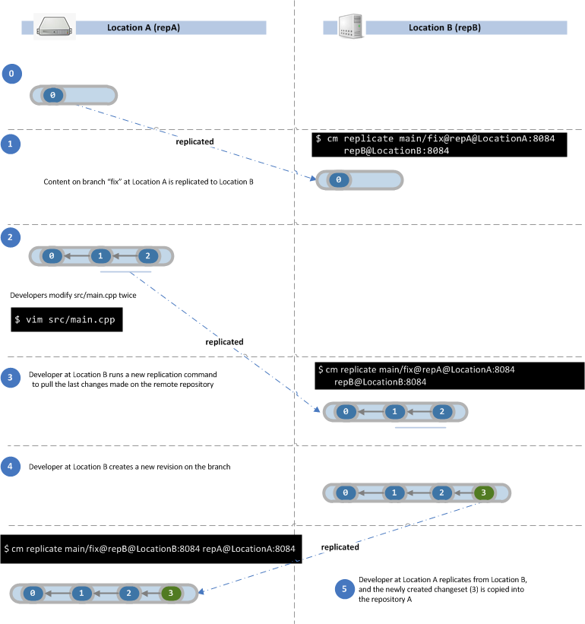

Figure 8. Replication: step by step explanation.

The sample focuses on a file named */src/main.cpp* at the branch *main/fix*. The branch is replicated from repository A at Location A to repository B at Location B. Note that the figure specifies the Plastic SCM command needed in order to run a replication.

At *step 1*, there is only one changeset on the two replicated repositories, containing the first change on /src/main.cpp.

*Step 2* shows how the file is modified at *rep A:* two new revisions are created.

At *step 3*, the developer at *location B* runs once more the same replication command. The two new revisions created at *rep A* are now copied into *rep B*.

During replication, Plastic SCM first pulls the changesets at the branch specified by the user (starting at the last previously replicated changeset if any). Then it will pull the changesets from the source repository. To do so, Plastic SCM finds the parent changeset of the new changesets being pulled, and links them accordingly.

At *step 4*, the developer at *rep B* makes a new change starting from the latest replicated changeset and modifying again *main.cpp*.

At *step 5*, the developer at *rep A* replicates */main/fix* at *rep B*. The newly created changeset *3* gets replicated and correctly placed in his repository.

Note that the example from Figure 8 shows only one change at a time on the branch, so no conflicts can happen. While following this strategy, the two replicated branches will continue being exact clones on replication.

Figure 9 shows a more complex scenario. Both locations start with the same configuration: three changesets at branch */main*.

At *step 2*, the two repositories evolve in parallel when the developers introduce new changes on *main.cpp*.

At *step 3*, the user at *rep A* tries to replicate changes from *rep B*. Now Plastic SCM can’t directly *link* revisions 3 and 4, created at *rep B* to revision 2 because a new revision 3 has also been created at the branch.

Note that internally Plastic SCM identifies each object by a GUID (Globally Unique Identifier[1]) so don’t get confused by the *changeset numbers* shown in the sample.

If changeset 4 at repA didn’t exist, then Plastic SCM would have placed revision 5 and 6 from rep B just right of the existing changeset 3. In this situation though, it can’t do that. So what Plastic SCM actually does is **create a subbranch** to place the replicated changesets.



Figure 9. Replication of branches modified at two locations

# Replication modes

There are two replication modes available:

* **Direct server-to-server replication:** A Plastic SCM client will tell the destination server to replicate a branch from a source server. Servers will communicate through internet or intranet connections to replicate data.
* **Package based replication:** A Plastic SCM client connects with the source server and creates a replication package. The package will be delivered in person (via USB drive, for example) and imported later on by the destination server.

Figure 10 depicts the two available replication modes.

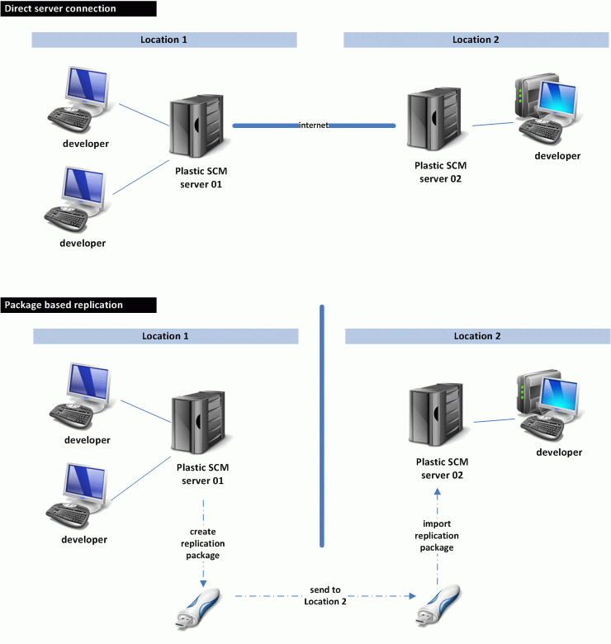

Figure 10. Replication modes

The *package based* replication introduces the ability to keep servers in sync which are not allowed to connect directly due to security restrictions.

# Replication from the command line

All the replication scenarios and possibilities described can be set up with a single Plastic SCM command: *replicate*.

cm replicate srcbranch destinationrepos

Where *srcbranch* is a branch spec identifying the branch to be replicated and its repository, and *destinationrepos* is the repository where the branch is going to be *replicated*.

## Direct server replication

Suppose you want to replicate the branch *main* at repository *code* at server *london:8084* to repository *code_clone* at *bangalore:7070*. The command would be:

cm replicate main@code@london:8084 rep:code_clone@bangalore:7070

## Replication packages

To replicate branches using *packages*, the first step will be creating a replication package, and then importing the package into another server.

Suppose you have to create a replication package for the main branch at repository *code* at server *box:8084*.

cm replicate br:/main@code@box:8084 **–package=box.pk**

The previous command will generate a package named *box.pk* with all the content of the main branch.

Later on, the package will be imported at the repository server *berlin:7070*.

cm replicate rep:code@berlin:7070 **–import=box.pk**

# Authentication

During replication, different servers have to communicate with each other. This means that servers running different authentication modes will have to exchange data.

To do so, the replication system is able to set up different authentication options.

## Setting up authentication modes

Figure 11 shows a typical scenario with a client and two servers. All the involved Plastic SCM components are configured to work in LDAP and they share the same LDAP credential, so no translation is required.

Note that authentication happens at two levels:

1. The client needs to be authenticated in order to connect to the *destination server*. In the figure, the destination server is *berlin*.
2. Then *berlin* will need to connect to the server *london* to retrieve information about the branch to be replicated (main in the sample).

If both servers were not using the same authentication mechanism or not authenticating against the same LDAP authority, step 2 would fail.

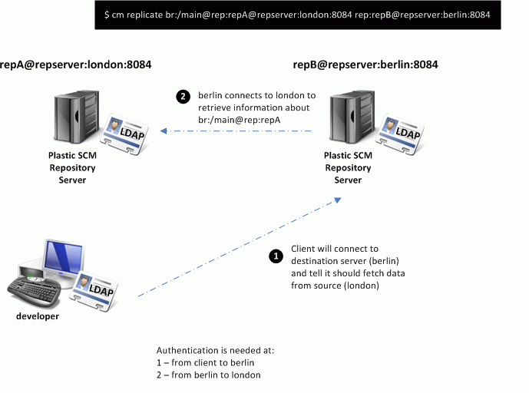

Figure 11. Distributed system authentication diagram

Figure 12 shows a scenario in which the server *london* is configured to use *user/password* authentication. In this case, a command like the one specified at the top of the figure will fail because authentication between servers won’t work at step 2.

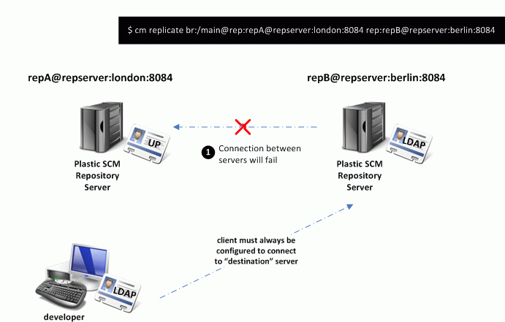

Figure 12. Specifying credentials to replicate between servers

To solve this problem, the replication system has the ability to specify authentication credentials to be used between servers. In the example, the client can specify to the server *berlin* a user and password to communicate with server *london*.

Figure 13 shows two different ways to specify authentication credentials when using *user/password* at the *source* server.



Figure 13. Two different ways to specify authentication credentials

The first option is actually specifying the mode plus the user and password (for UP) at the command line.

The second one uses an *authentication* file, which is useful when authentication credentials are going to be used repeatedly. As the figure shows, an authentication file is a simple text file containing two lines:

* **Authentication working mode:** UPWorkingMode, LDAPWorkingMode, NameWorkingMode, ADWorkingMode, or NameIDWorkingMode
* **Specific authentication data for the authentication mode.** The data specified in the second line is exactly the same data in the SecurityConfig section of the configuration file *client.conf*.

Suppose now that replication must happen in the opposite direction, from *berlin* to *london* as Figure 14 shows. The parameters to connect to an LDAP server (in this casean *Active Directory* accessed through LDAP) are specified. Normally in LDAP an *authentication* file will be used to ease the process.

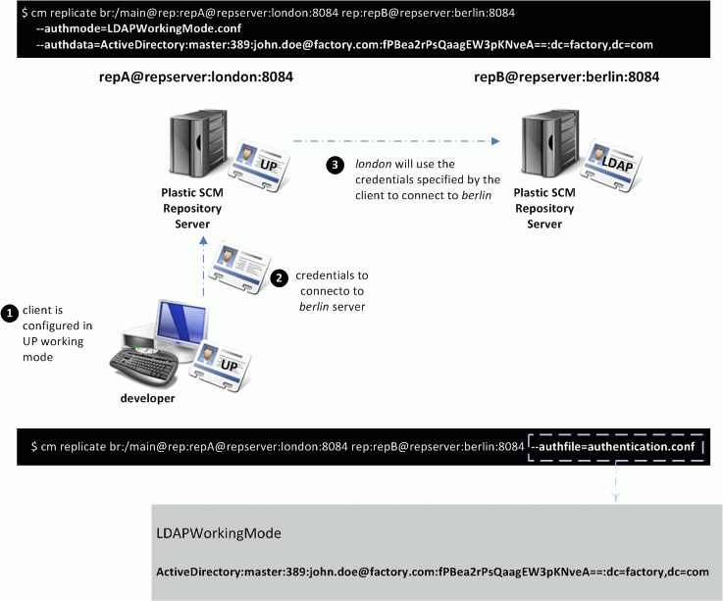

Figure 14. UP server communicating with LDAP one

***Not*e:** If replication is performed through *replication packages,* the client needs to be able to connect to the source or destination servers, depending on whether it is performing an export or import operation.

## Translating users and groups

When replication is performed between servers with different security modes, authentication is not the only issue. User and group identifications have to be translated between the different security modes.

The sample at Figure 15 tries to replicate from a *user/password* authentication mode to an LDAP based one. The user list at the UP node stores plain names but the user list at the LDAP server stores SIDs. When the owner of a certain revision being replicated needs to be copied from repA to repB, a user or group will be taken from the user list at repA and introduced into the list at repB. If a name coming from repA is directly inserted into the list at repB, there will be a problem later on when the server at *berlin* tries to resolve the LDAP identifier because it will find an invalid one: The user identifiers in *user/password* mode won’t match those of the LDAP directory and the user names will be wrong in the replicated repository.

So in order to solve the problem, translation will be needed.

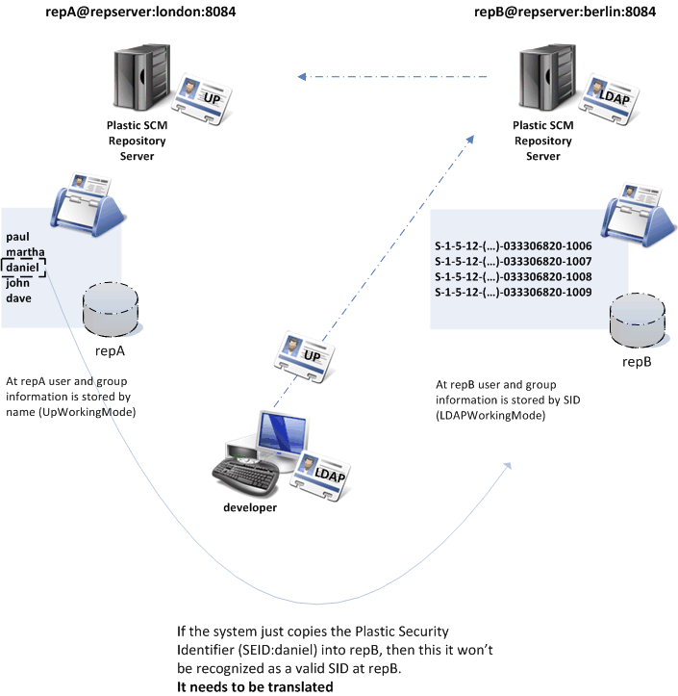

Figure 15. User and group translation on replication

The Plastic replication system supports three different *translation modes*:

* **Copy mode:** This is the default behavior. The security IDs are just copied between repositories on replication. This only works when the servers hosting the different repositories work in the same authentication mode.
* **Name mode:** Translation between security identifiers is done based on name. In the sample at Figure 15 suppose user *daniel* has to be translated by name from repA to repB. At repB, the Plastic SCM server will try to locate a user with name *daniel* and will introduce its LDAP SID into the table if required.
* **Translation table:** This also performs a translation based on name, but is instead driven by a table. The table, specified by the user, tells the destination server how to match names. It tells how a source user or group name has to be converted into a destination name. Figure 16 explains how a translation table is built and how it can translate between different authentication modes.

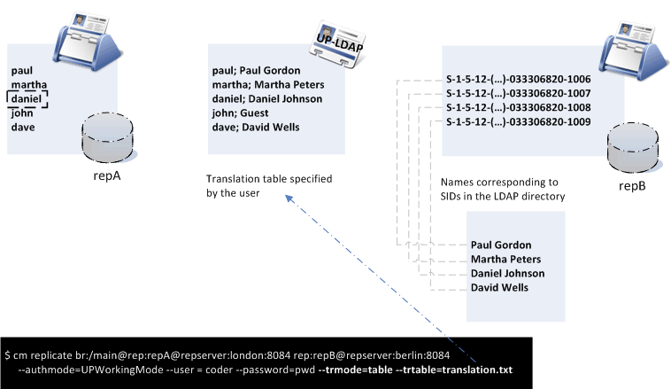

Figure 16. Translation table explained

**Note:** A translation table is just a *plain text file* with two names per line separated by a semi-colon “;”. The first name indicates the user or group to be translated (source) and the second one indicates the destination.

# Replication from the graphical interface

Replication can be done from both the command line interface (CLI) and the Plastic Graphical User Interface (GUI) tool. All the possible actions are located in a submenu under the *branch* options, because replication is primarily related to branches. This topic will describe how to perform the most common replication actions from the GUI.

## Replication actions

In the GUI, replication and distributed collaboration has been organized in the following actions:

1. Branch actions:
   1. Push the selected branch
   2. Pull the selected branch
   3. Pull a remote branch
2. Package actions:
   1. Create a replication package from the current branch
   2. Create a replication package from a branch
   3. Import a replication package

Figure 17 depicts the different available operations. From the command line, all the operations are issued from a single command, but the GUI makes a distinction between *push* (move changes from your server to a destination) and *pull* (bring changes from a remote repository to yours) actions.



Figure 17. GUI replication actions

## Replication menu

As was mentioned before, all replication actions can be accessed from the branch menu (check Figure 18).

The options *push this branch*, *pull this branch,* and *create replication package from this branch* are related to the branch currently selected in the branch view. The other options: *pull remote branch*, *create replication package,* and *import replication package* are generic replication actions which are not constrained to the current branch, but are instead located under the branch menu to keep all the replication options together.

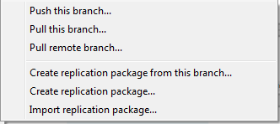

Figure 18. Replication options in GUI branch menu

## Pushing your changes to a remote repository

Whenever you want to push your changes to a remote repository, select *push this branch* on the branch menu. *Pushing* your changes means sending the changes made on the selected branch to a remote repository.



Figure 19. Pushing changes

If the branch already exists in the destination repository, the changes will be *synchronized.* A warning message will show up if there are conflicting changesets in the destination. Then, the developer will have to reconcile changes by first pulling the branch to the local server and then pushing it, once the merge conflicts have been resolved.

If the branch doesn’t exist in the destination repository, a new branch will be created (identified by the same GUID used on the source repository).

See Figure 19 for a detailed explanation.

## Synchronizing your branch with remote changes

Once you’ve pushed your branch to a different repository, the branch can be modified remotely. At some point in time, you’ll be interested in retrieving the changes made remotely to your branch. In order to do that, you have to use the *pull this branch* action from the replication branch menu.

The dialog box depicted in Figure 20 is very similar to the one used to push changes, but this time, your server is located on the right as *destination* of the operation.

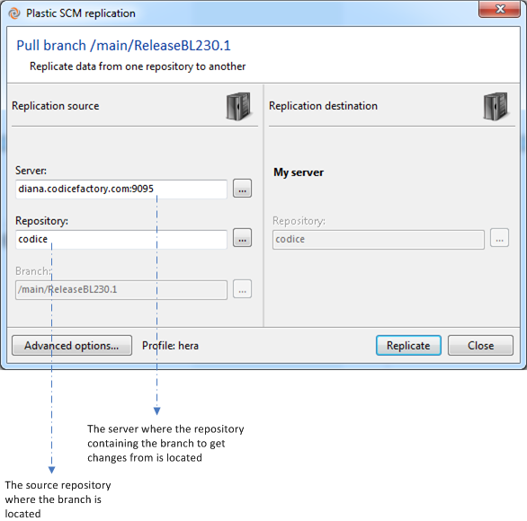

Figure 20. Pull changes from a remote branch

When you pull changes from a remote branch, a *subbranch* can be potentially created if there are conflicting changesets on the two locations.

## Importing a remote branch

Another common scenario during replication is importing a branch from a remote repository into yours in order to start making changes or create child branches from it.

In order to perform the import, use the *pull remote branch* option. The dialog box shown in Figure 21 will be displayed. Notice that this time you can choose the source server, repository, branch, and destination repository on your server.

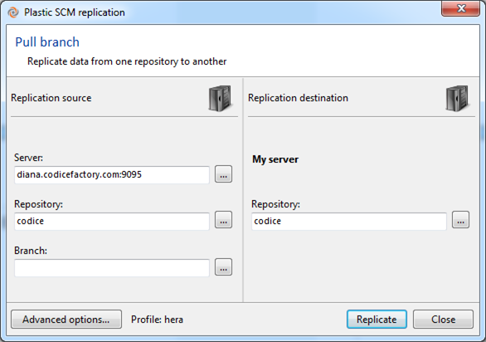

Figure 21. Pull a remote branch

## Managing remote authentication

As it was described in chapter 7, different Plastic SCM servers can use different authentication modes. By default, when you try to connect to a remote server, you’ll be using your current profile (the configuration used to connect to your server). Sometimes, though, the default profile won’t be valid on the remote server.

In order to configure Plastic SCM to be able to connect with a remote server with different authentication mode, use the *advanced options* button on the replication dialog. It will pull up a dialog like the one in Figure 22.

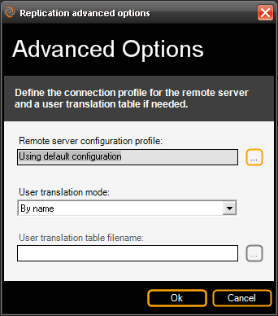

Figure 22. Advanced options dialog – I3 visual theme

The dialog box shows the profile currently selected (the *default one* on the screenshot) and also the translation mode (refer to chapter 7 for more information) and the optional translation table.

You can have different authentication profiles created from previous replication operations, and you can list them or create new ones by pressing the *browse* button located on the right of the *remote server configuration profile* edit box.

It will display a dialog box like the one in Figure 23 which will allow you to select, edit, create, or remove a profile.

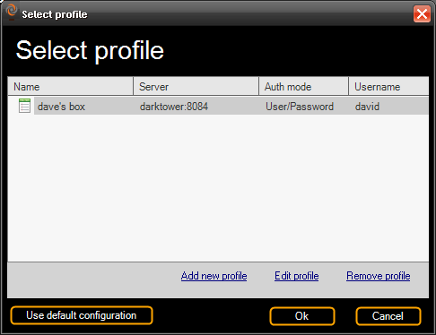

Figure 23. Profile selection dialog – I3 visual theme

**Note:** The *replication dialog box* will try to choose a profile automatically each time you change the server. It will look for the most suitable profile based on the server information provided.

## Running the replication process

So far, all the steps have been focused on setting up the replication process. Once the operation is correctly configured, press the *replicate* button and you’ll actually enter the replication progress dialog box as explained in Figure 24.

The replication operation is divided into three main states: fetch metadata, push metadata, and transfer revision data. The first one happens on the source server, the second one on the destination server, and the third one involves the two servers as data is transferred from the source to the destination.

At any point in time, the operation can be canceled pressing the cancel button.

When the replication operation finishes, a summary is displayed, containing detailed information about the number of objects created.



Figure 24. Replication operation progress – I3 visual theme

## Creating a package

A replication package can be created from a branch on your repository or from any branch on any server you can connect to. In order to create a package from the selected branch in the branch view, click on *create replication package from this branch*. If you want to create a package from *any* remote branch, click on *create replication package* on the replication menu.

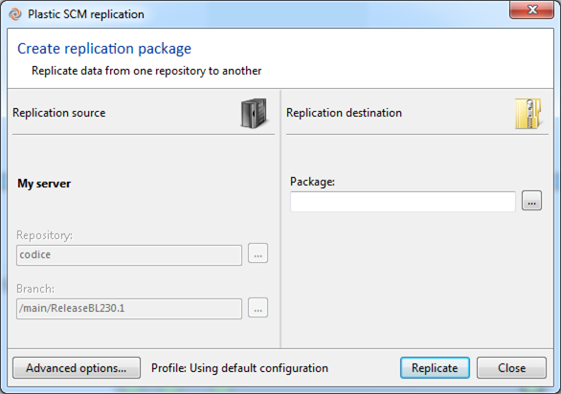

Figure 25. Create replication package from the GUI

Figure 25 shows the package creation dialog. It will generate a replication package from the selected branch which will contain all data and metadata from the branch. It can be used to replicate between servers when no direct connection is available.

## Importing a replication package

From the replication menu select *import replication package* and select a package file to be imported. The dialog box is shown in Figure 26.

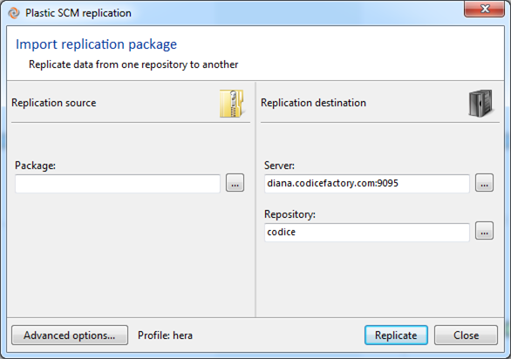

Figure 26. Import a replication package

# Distributed Branch Explorer

The Branch Explorer is one of the core features in the Plastic SCM GUI and it has been greatly improved in recent releases to be able to deal with distributed scenarios. That’s the reason why it now receives the “distributed” Branch Explorer name. Its short-hand name is DBrEx.

## How the DBrEx works

Consider two replicated servers. The second one has first replicated the “main” branch from the first, and later a second branch was created and developers worked on it. At a certain point in time it will look like Figure 27.

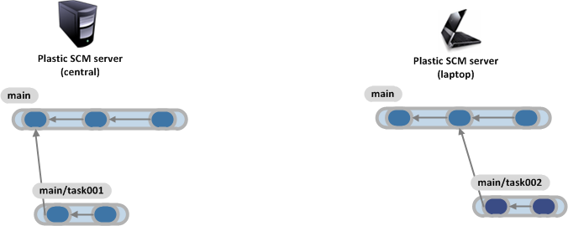

Figure 27. Distributed scenario with two servers

At this point, each of the servers contains part of the development, but prior to 4.0, there wasn’t a good way to understand the whole branching schema other than connecting and browsing each repository Branch Explorer separately.

The DBrEx is able to render a distributed diagram by collecting data from different sources and then rendering the changesets and branches on a single diagram as the Figure 28 shows.

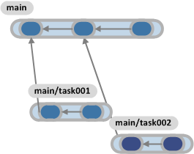

Figure 28. DBrEx draft

The DBrEx will combine the different sources and create an interactive diagram with the information gathered from the different sources.

## Rendering multiple repository sources on the DBrEx

There are several options in order to combine more than one replicated repository into the same DBrEx diagram. The first one is used to create a combined render including all the changesets and branches coming from the selected replication sources. Figure 29 shows you how to start configuring the diagram.

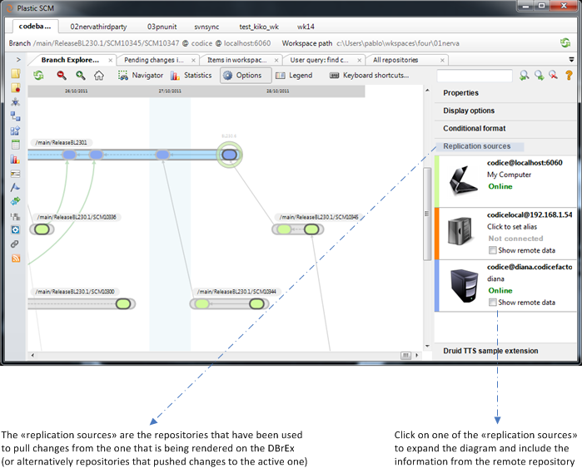

Figure 29. Options to combine remote repositories on the DBrEx

Once you click on one or more replication sources the distributed diagram will be rendered as depicted in Figure 30.

This way, the Distributed Branch Explorer introduces a new way to understand how the project and branches evolve across different replicas.

It is also possible to run the replication operations from the DBrEx, so pulling a remote branch is now as easy as selecting the remote branch rendered in the DBrEx and clicking on “pull this branch”. Remote branches and changesets are available for “diffing” too, which greatly enhances your work with distributed changes.

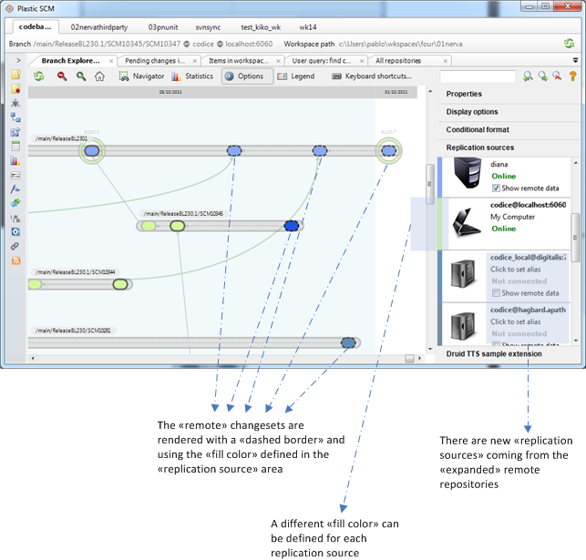

Figure 30. Remote changesets rendered on the branch explorer

## Diffing remote branches and changesets

It is possible to right-click a remote branch or changeset on the DBrEx to explore and understand what was modified remotely. This way developers or integrators can better understand what changes are going to be pulled from the remote sources prior to completing the operation. The following figure shows the options enabled on a remote changeset.

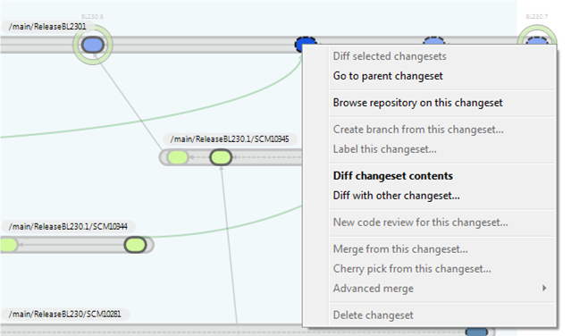

Figure 31. Menu options (diffing) on remote changesets

## Enabling the DBrEx for a single branch

Sometimes it is not necessary to render the whole distributed diagram because the SCM manager or developer needs to focus on a specific branch only.

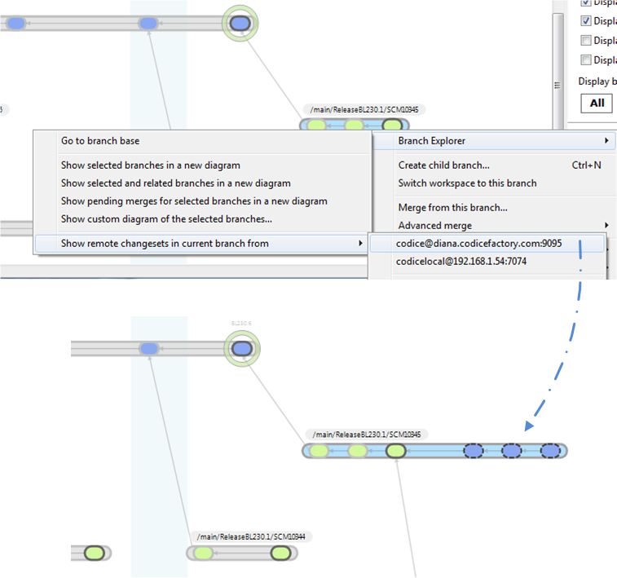

Figure 32. Single branch extended with remote information

Figure 32 shows the Branch Explorer / Show remote changesets menu option which allows you to select a remote source to decorate a branch with remote data to understand what needs to be pulled, see explorer differences, and trigger replication commands.

# Synchronization View

Plastic SCM is all about helping teams to embrace distributed development. To do so, we enhanced the DBrEx, but in order to deal with hundreds of distributed changesets, a new perspective has been created: the distributed view.

The Sync View enables you to synchronize any pair of repositories easily, browsing and diffing the pending changes to push or pull.

## Creating a new Sync View

In order to take advantage of the new Sync View it is necessary to configure one. The entry point to the Sync View has been placed on the left menu bar as depicted by Figure 33.

The entry point will let you browse all the defined sync views once you’ve created them.

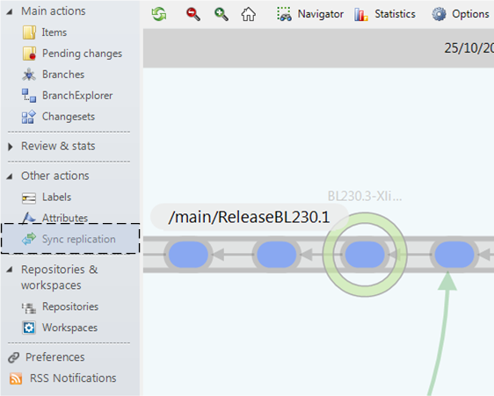

Figure 33. Sync view entry point on the menu

A synchronization configuration is about selecting a source repository and a destination repository and then running them to find the outgoing and incoming changesets.

The Figure 34 guides you through the process of setting up a sync view.



Figure 34. Creating a new sync view

## Source and destination explained

Whenever you define a new sync view configuration, you’ll have to define a repository source and a destination.

* You can set up a sync view with your code repo at your laptop as source and your project repo at the central server as destination to use it to push and pull changesets from your central server to your laptop and vice versa.
* You can set up a sync view between your main server and a mirror, to use it to keep the mirror in sync.
* You can set up a sync view to keep two servers, at two distant locations, in sync.

## Sync view details

The details of the sync view shows the branches to be synchronized grouped in “outgoing” and “incoming” and then containing the related changesets. Figure 35 shows a sync view containing the mentioned details.

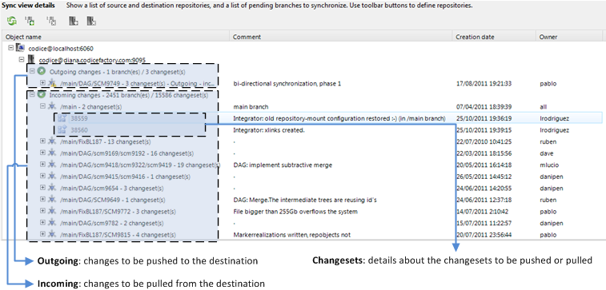

Figure 35. Sync view details

The menus available for the destination repository, branches, and changesets are depicted in Figure 36.

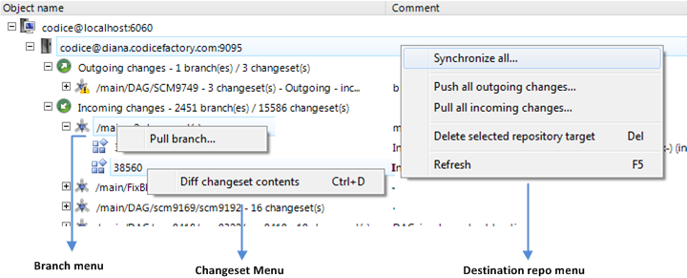

Figure 36. Available menus for sync view details

## Several sources and destinations on a single view

As Figure 37 shows, it is possible to define more than one source-destination pair on a single view. This is useful when you need to replicate more than one repository between the same two servers.

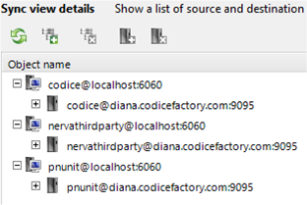

Figure 37. More than one source/destination pair on a sync view

1. http://en.wikipedia.org/wiki/GUID